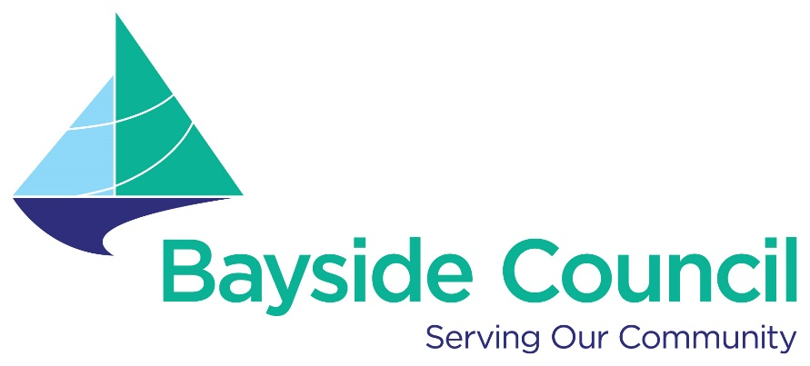

Disability Inclusion Action Plan
Working Group
Terms of Reference

Last updated 7 March 2023

Bayside Council acknowledges the Traditional Custodians, the Gadigal/Bidjigal people of the Eora Nation. The people of the Eora Nation, their spirits and ancestors will always remain with our waterways and the land, our Mother Earth.

© Bayside Council

Disability Inclusion Action Plan Working Group Terms of Reference
File: Document:
Class of document: Terms of Reference

Enquiries: Manager Community Life
Contents

1 Introduction 4
2 Explanation of Terms and Acronyms 4
3 Background 5
4 DIAP Working Group Objective 5
5 Status of DIAP Working Group 5
6 Delegations 5
7 Membership 6
7.1 Chair and Deputy Chair 6
7.2 Quorum 6
7.3 Term of the Working Group 6
8 Other attendance at the Working Group Meetings 6
8.1 Additional Expertise 6
8.2 Council staff 7
9 Meeting schedule 7
10 Meeting practices and procedures 7
11 Remuneration 7
12 Confidentiality & Privacy 7
Document control 8
12.1 Review 8
12.2 Version history 8

Introduction
Bayside Council is committed to making our community more inclusive to ensure everybody has the same opportunities to participate in every aspect of community life.

Council’s Disability Inclusion Action Plan 2022 - 2026 outlines how Council will improve and maintain access and inclusion for people with visible and invisible disabilities living and working in our community.

Council’s Disability Inclusion Action Plan (DIAP) Working Group has a commitment to establish and maintain an effective Working Group to drive and implement the actions in the plan.

- Council DIAPs must be reviewed annually.

- The DIAP will be consulted and developed (not just reviewed) every four years.

The Disability Inclusion Action Plan (DIAP) Working Group will include people with disability across our community including:

- Aboriginal and Torres Strait Islander people
- People with culturally and linguistically diverse backgrounds
- Women
- LGBTIQ community members

Explanation of Terms and Acronyms
Explanation of terms in this document:

DIAP means the Disability Inclusion Action Plan 2022 2026.

Member means a member of the Disability Inclusion Action Plan Working Group.

Working Group mean Disability Inclusion Action Plan Working Group.

Council means Bayside Council.

Chairperson means the person on the Working Group that takes on the role to guide the meetings as determined by the Council’s Code of Meeting Practice.

Disability means ‘The long-term physical, mental, intellectual or sensory impairment which in interaction with various barriers, may hinder the full and effective participation in society on an equal basis with others. This definition is from The Disability Inclusion Act 2014.

Background
The establishment of the DIAP Working Group provides a framework to ensure:
- There is active engagement, consultation and representation from people with disability living and working in the community.
- The DIAP is integrated into Council culture, goversnance and practice.
- Empowerment and support for people with disability to drive the actions in the DIAP 2022 – 2026.
- That people with disability can fulfil their potential as equal members of the community and participate in council life.

DIAP Working Group Objective
The primary objective of the Working Group is as follows:

- Bring people with lived experience and peak organisations representing people with disability to support the implementation, monitoring and ongoing development of the DIAP.
- To empower people with disability to inform the actions in the DIAP.
- To provide a framework to address the major focus areas in the DIAP through engagement, consultation, governance, and accountability.
- To support the integration of the DIAP into council’s organisational culture.
- Improve communication, collaboration and education through information sharing between Council, people with disability and community.

DIAP Working Group
The Working Group is an operational working group established by Bayside Council via:

- An Expression of Interest distributed to the community.
- Special invitation issued to people with disability and specialist service providers.
- Appointed by the General Manager or his/her delegate.

Delegations
The Working Group may make recommendations to Council on all matters before it. These recommendations will be endorsed by the Working Group and submitted to Manager Community Life for consideration and/or presentation to Council.

The Working Group does not have the power to incur expenditure, nor do they have the power to bind Council or the Administration.

Membership
The Working Group comprises of representatives from people with disability and disability support services in the Bayside local government area.

Community representatives will be sought via Expression of Interest, who include people who identify as having a disability aged 18+ years living, working, or volunteering in the Bayside local government area. The General Manager will appoint up to (six to ten) community representatives to be members of the Working Group.

Chair and Deputy Chair
The Chairperson and Deputy Chairperson will be elected by members of the Working Group at its first meeting, as its first item of business.

Quorum
The quorum for the Working Group is half the total members plus one and at least one staff member.

Working Group meetings are not open to the general public.

Term of the Working Group
Unless otherwise stipulated by the General Manager, Working Group members are appointed for the term of the current DIAP.

Any casual vacancy in community membership is to be filled from expressions of interests which will be publicly advertised. If the vacancy cannot be filled from existing expressions of interests, a fresh call for nominations will be issued.

From time to time, Bayside Council may appoint other members to the Working Group to suit the matters under consideration.

Other attendance at the Working Group Meetings

Additional Expertise
As required, the Chairperson or Manager Community Life may invite other representatives to address issues that require subject matter expertise.

Invited representatives would attend at the invitation of the Chairperson or Manager Community Life and may be requested to leave the meeting at the conclusion of their presentation(s).

Council staff
The Working Group is supported by Council officer(s), who provide technical advice and support, and secretariat services. The Working Group will be supported by Bayside Council Community Development Disability Specialist. This will include compiling and circulating agenda and relevant documents to all members, taking and distributing minutes of each meeting, and reporting on progress against DIAP deliverables.

Meeting schedule
The DIAP Working Group will meet quarterly except during the months of December and January. The meeting schedule will be determined during the first session of the Working Group, with dates and venue communicated to members in advance of each meeting. The frequency and location of meetings may be varied by the Chairperson in consultation with Manager Community Life.

The location, date and time of meetings will be determined by the DIAP Working Group giving consideration to members’ access, travel and ability to attend meetings.

Meetings will be face-to-face, via Zoom and or Teams depending on members access requirements.

Meeting practices and procedures
The administrative provisions for the DIAP Working Group are outlined in Council’s Code of Meeting Practice apply, unless varied by these Terms of Reference. All members of the Working Group must comply with Council’s Code of Conduct.

The proceedings of each meeting are recorded in minutes of the meeting, including those present, apologies, conflict of interests and recommendations on matters before the Working Group. The minutes and agenda will be sent to all members of the working group before each meeting.

Remuneration
The Working Group is an operational advisory body. Members will not be remunerated. Members without transport may be offered transport to meetings by Council officer(s) or provided with travel vouchers to attend meetings.

Confidentiality & Privacy
Working Group members may have contact with confidential or personal information retained by Council. As such, members are required to maintain the security of any confidential or personal information and not access, use or remove any information unless the member is authorised to do so.

Members are not permitted to speak to the media in their capacity as Working Group members.
Privacy legislation governs the collection, holding, use, correction, disclosure, and transfer of personal information. More information about the legislation can be obtained by contacting the Manager Governance & Risk.
Should a member of the working group become aware of any breach of security or misuses of Council’s confidential or personal information, that person is to contact the General Manager or Manager Governance & Risk.
All Working Group members and staff are required to observe the provisions of Bayside Council’s Privacy Management Policy relating to their access to personal information.

Document control

Review
The DIAP Working Group and these Terms of Reference are reviewed every four years in line with the Disability Inclusion Action Plan time frames.

Apart from any inconsequential editing, amendments to these Terms of Reference are approved by the Executive Committee.

Version history
Version | Release Date | Author | Reason for Change
Draft | January 2023 | Community Development Disability Specialist | New document
1.0 | January 2023 | Manager Community Life | Approved
2.0 | March 2023 | General Manager | Approved

