Health and wellbeing
- Maintain your daily routine:
- wake up at your normal time
- get dressed for the day
- keep regular meal times
- go to bed at your usual bedtime
- Do an online gym workout:
- No Running Cardio https://www.healthier.qld.gov.au/fitness/workouts/no-running-cardio/
- https://darebee.com/
- PlanetFitness FaceBook page
- 7 Minute workout app
- Nike Training Club app
- Get creative with your workouts:
- grab some cans of food or fill some water bottles for bicep curls
- add weight to your squats with bags of flour
- Join the 100 Club- choose an exercise and do this 4 times per day (25 reps each time)- squats, lunges, push ups, sit ups, tricep dips
- Track physical activity and food/water intake via MyFitness Pal
- Practice breathing exercises
- Calm Breathe Bubble on youtube
- Relax and Breathe: Do nothing for 10 minutes on youtube
- Staying positive and fun daily challenges on SuperBetter app
- Practice mindfulness: can use apps eg headspace, 1GiantMind, smilingmind
- Meditate
- Yoga online workouts eg https://www.youtube.com/user/yogawithadriene
- Pamper yourself and put on a face mask
- Give yourself a manicure and hand massage
- Soak in a bubble bath or have a relaxing shower
- Put on essential oil diffusers eg lavender smell
- Listen to your favourite music

Get creative

- Make a photobook online eg www.snapfish.com.au, www.vistaprint.com.au
- Colour in (https://www.bigw.com.au/books/non-fiction-books/adult-colouring-books/c/780301/)
- Take up craft: sewing, knitting, quilting, drawing, painting, jewellery making, origami, calligraphy, poetry – check out pinterest or yoube for some ideas
- Try some scrapbooking or collaging eg use magazines or newspapers or photos
- Pick some flowers from the backyard and try some flower arranging
- Start a gratitude or dream journal
- Create a list of things to be happy about and try to add one thing to it every day
- Make a paper plane
- Do a photography project
- Draw an apple using a different style everyday for a week
- Paint landscapes of where I want to go in the future
- Write a poem or story
- Make some joke cards
- Try a relaxing app eg Colour by numbers
- Daily Art app for your daily dose of art history
- Make a cook book with all your favourite recipes
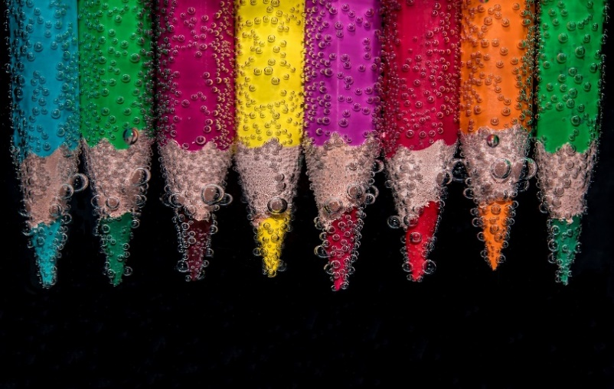

Staying socially connected
- Call friends, family members, coworkers, neighbours
- Zoom/Skype/Facetime/Houseparty app with friends and family
- Set dates to watch the same tv show with friends and message each other your thoughts throughout- think virtual Gogglebox
- Start a movie or book club and schedule weekly virtual meetings
- Write letters/emails/ make a card to stay connected and let people know you are thinking of them
- Host a karaoke night with friends through Zoom/Skype
- If you are in a position to, drop off some ‘Neighborhood Check-in cards’ to neighbours who may need support phone calls or grocery items picked up

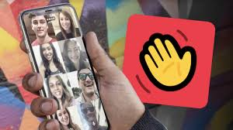

Music
- Explore The Berlin Philharmonic Digital concert hall online https://www.digitalconcerthall.com
- Listen to some happy songs eg https://www.usatoday.com/story/entertainment/music/2020/03/20/coronavirus-100-songs-listen-while-youre-stuck-at-home/2882725001/
- Journey through some French music
- https://open.spotify.com/track/6WBcCwfTB0pmtXKcTq5g1X
- https://open.spotify.com/track/6M4nkEPZMj58acftDRTuKL
- https://open.spotify.com/track/1MOmmxRf8i3a6yt6huEiMm
Keeping your mind active
- Learn a language via free apps eg Duolingo
- Read a book, electronic book or listen to an audio book eg https://librivox.org/
- Read a magazine eg Breathe
- Read some daily inspiration eg The stoic app
- Try some free online learning www.futurelearn.com
- Listen to a podcast via Apple podcasts app, Google podcasts app, Spotify, TEDRadio Hour, Stuff you should know, Goodlife Project
- Watch Ted talks eg ‘All it takes is 10 mindful minutes’, ‘The power of mindfulness’
- Follow the Recovery College Facebook page for updates on online courses
- Learn an instrument
- Brain games eg luminosity
- Puzzle
- Sudoku
- Crosswords
- Board games
- Play a card game eg Uno, solitaire
- Download the SkyView app to view distant constellations, nearby planetary objects and more
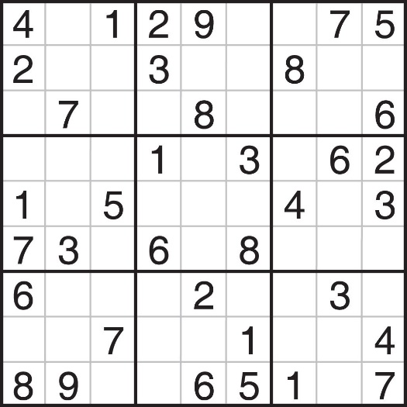
Culture
- Electronically-visit a museum:
- British Museum https://britishmuseum.withgoogle.com/
- New Mexico Museum of Art Searchable Art Museum http://sam.nmartmuseum.org/collections
- Guggenheim Museum via Google Arts and Culture
https://www.guggenheim.org/plan-your-visit/guggenheim-from-home
- The Louvre https://www.louvre.fr/en/visites-en-ligne
- Watch Live Zoo Cams:
- Zoos Victoria https://www.zoo.org.au/animal-house/
- San Diego Zoo https://zoo.sandiegozoo.org/live-cams
- Monterey Bay Aquarium https://www.montereybayaquarium.org/animals/live-cams
- Atlanta Zoo Panda Cam https://zooatlanta.org/panda-cam/
- Explore your genealogy and family tree
- Catch up on some classic movies you’ve never seen
- Research something you have always wondered about
- Watch opera live streams on www.metopera.org
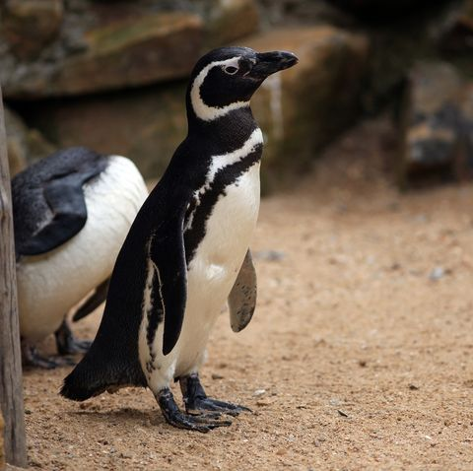
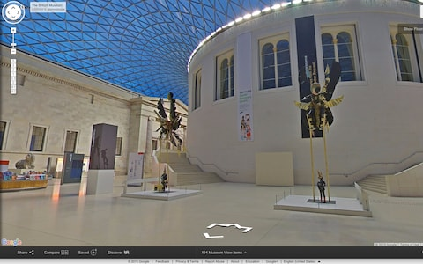

Housekeeping

- Clear out your wardrobe
- De-clutter your home (look at 10 Amazing Tips from Tidying Up with Marie Kondo on youtube for some inspiration):
- tidy your kitchen
- tidy your bathroom
- tidy your garage
- Organize your beauty cabinet
- Clean your make-up brushes
- Cooking challenge: make something with the ingredients in your cupboard
- Go through your phone camera roll to cull your photos
- Edit photos on your computer
- Delete all the apps you don’t use and discover some new ones
- Give some of your odd jobs at home ago that you often put off: re-arrange your lounge room furniture, put some items in storage
- Get out in your garden and do some weeding
- Go electronic- scan documents, get rid of unnecessary paper and create a computer filing system
